2024-26-02

IHP opens Joint Lab with the University of Roma Tre
Research for intelligent electro-optical sensing

Frankfurt (Oder). The joint research of IHP – Leibniz Institute for High Performance Microelectronics and Department of Sciences of the Italian Roma Tre University has reached a new level. Last week, the Joint Lab on "Intelligent electro-optical sensing" was officially opened. Prof Paolo Visca and Prof Alessandra Di Masi came to Frankfurt (Oder) for this occasion.
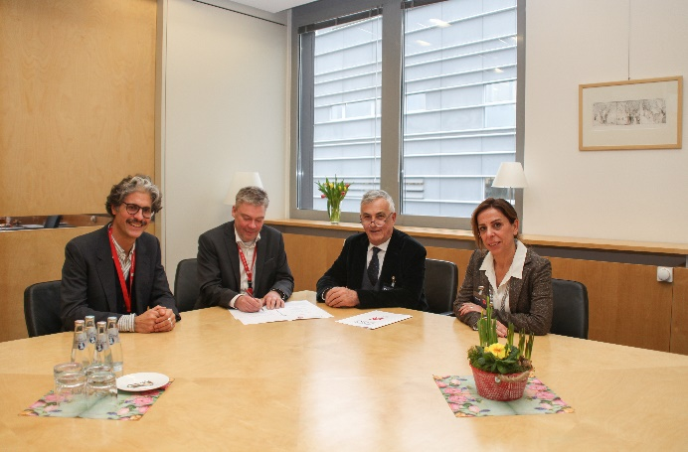
The international Joint Lab is rooted in a long-term partnership between the two institutions, focused on common research and educational activities in the field of semiconductors materials for optoelectronic applications. "We exploit synergies to work together on innovations," says Prof Giovanni Capellini. He is a professor at the University of Roma Tre and a member of the IHP materials research team, and as such will coordinate the future collaboration. He explains: "Leveraging on the multiple and complex interactions between nanomaterials and biological systems, the research focus of the Joint Lab is the development of intelligent electrooptical sensing platforms." The focus of the future collaboration is basic research on the development and engineering of group-IV semiconductor SiGeSn semiconductor materials & graphene towards the realization of silicon based electronic-photonic integrated circuits. Another focus will also be on developing innovative devices and systems that give silicon-based technology new functionalities. "We are thinking, for example, of biomolecule sensing, tissue engineering, regenerative medicine and diagnostic procedures," adds Prof Capellini.
Joint cooperation: Prof Giovanni Capellini and Prof Gerhard Kahmen from IHP discussed future cooperation with Prof Paolo Visca, vice rector of Research, and Prof Alessandra Di Masi from the University Roma Tre. (from left to right)
© IHP 2024/Franziska Wegner

At the opening ceremony, Prof. Dr Alessandra di Masi emphasized the overlap between the two institutions. "As the University of Roma Tre, we contribute to the Joint Lab with know-how, labs, and human resources in the realms of biochemistry and biotech, chemistry of surfaces, and condensed matter physics. We will synchronize our procedures with those tested at the IHP. We offer our students a high-quality training that combines theoretical instruction with practical laboratory sessions to address the demands of the job market," she said. The University of Roma Tre has around 35,000 students. 4 of the 13 departments have been recognized as Department of Excellence by the Italian government, placing them in the top 10% of the country. The Department of Science has received this honor for the second time in a row.

"With its thematic range, the Joint Lab offers a great opportunity and a lot of potential for a long-term, productive collaboration in which the partners complement each other. On the other hand, this matches the interdisciplinary approach of the Leibniz Association very well," says Prof Gerhard Kahmen, Scientific Director of IHP. "With our Joint Lab, we strengthen contacts that significantly help to attract qualified and motivated young scientists. They are a model for success in the field of cooperation." The IHP currently operates nine Joint Lab, three of them are international.
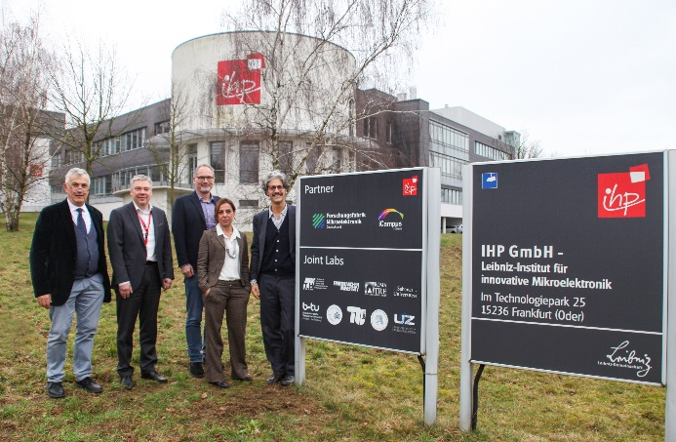

A sign of collaboration: The logo of the University of Roma Tre complements the signpost for the IHP Joint Lab. Prof Paolo Visca, Prof Gerhard Kahmen, Prof Christian Wenger, Prof Alessandra Di Masi and Prof Giovanni Capellini inaugurated the sign during the opening ceremony.
(from left to right)
© IHP 2024/Franziska Wegner

PR Contact:
M.A. Franziska Wegner
Public Relations
IHP GmbH – Innovations for High Performance Microelectronics/
Leibniz-Institut für innovative Mikroelektronik
Fon: +49 (335) 5625 205
E-Mail: wegner@ihp-microelectronics.com
Im Technologiepark 25
15236 Frankfurt (Oder)

About IHP:
The IHP is an institute of the Leibniz Association and conducts research and development of silicon-based systems and ultrahigh frequency circuits and technologies including new materials. It develops innovative solutions for application areas such as wireless and broadband communication, security, medical technology, industry 4.0, automotive industry, and aerospace. The IHP employs approximately 365 people. It operates a pilot line for technological developments and the preparation of high-speed circuits with 0.13/0.25 µm SiGe BiCMOS technologies, located in a 1500 m² DIN EN ISO 14644-1 3 certified clean room.
www.ihp-microelectronics.com

