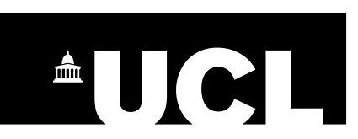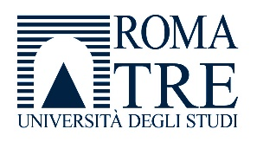

Avviso di selezione per la partecipazione gratuita alla
UCL/Roma Tre/British School at Rome Turing Summer School
Rome: The Heritage of Modernity
21-30 giugno 2022
Si avvisano gli studenti delle LM in Italianistica (LM-14) e Lingue e Letterature per la Didattica e la Traduzione (LM-37) che dal 15 al 31 maggio 2022 sarà possibile candidarsi per la partecipazione gratuita alla UCL/Roma Tre/British School at Rome Turing Summer School Rome: The Heritage of Modernity, organizzata con la collaborazione del Dipartimento di Studi Umanistici e del Dipartimento di Lingue Letterature e Culture Straniere, che si terrà a Roma dal 21 al 30 giugno 2022. Il programma è in allegato al presente bando.
Alla Summer School sono ammessi, a titolo gratuito, 6 studenti della Laurea Magistrale in Italianistica (LM-14) e 6 studenti della Laurea Magistrale in Lingue e Letterature per la Didattica e la Traduzione (LM-37).
La domanda va effettuata compilando on line il form al seguente link entro e non oltre le ore 23.59 del 31 maggio 2022:
https://forms.office.com/r/VPedizW3NV
I criteri di selezione saranno i seguenti:
media ponderata 30/100
numero di esami sostenuti 30/100
lettera motivazionale 20/100
livello di competenza nella lingua inglese 20/100 (richiesto almeno un livello B2)

La frequenza delle attività e la redazione di un blog post e di una tesina finale daranno la possibilità di ottenere 6 cfu nell’ambito F (Stages, tirocini, laboratori, altre attività).
I corsi saranno tenuti in lingua inglese.

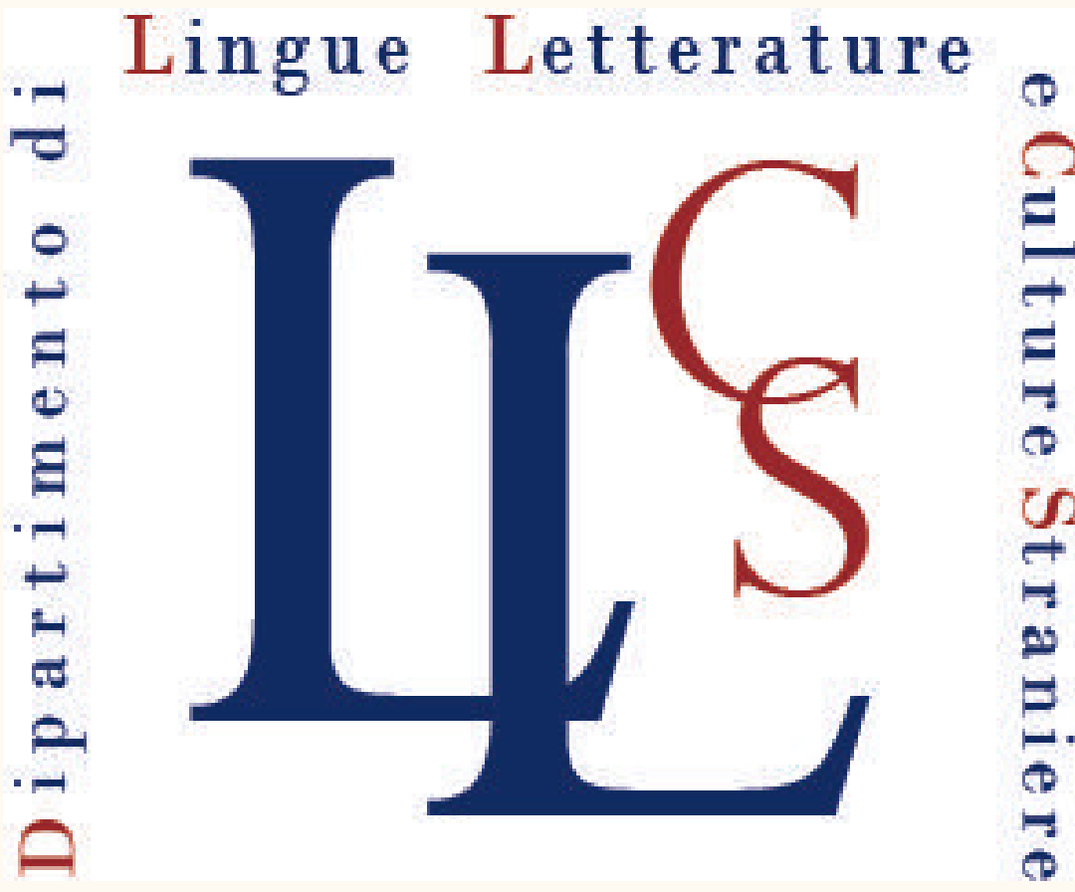

Allegato A: Programma:
UCL/Roma Tre/British School at Rome Turing Summer School
Rome: The Heritage of Modernity
21 giugno-30 giugno 2022

Convenor: Florian Mussgnug (Professor of Comparative Literature, University College London and Roma Tre University)
Tutors: Beatrice Sica (Associate Professor in Italian Studies, University College London); Simon Martin (Research Fellow, British School at Rome); Ilyas Azouzi (Ralegh Radford Rome Awardee, British School at Rome)
The Summer School has a dual focus: (a) it explores the difficult cultural, architectural, and political legacy of Italian Fascism in contemporary Rome; (b) it explores Rome as a multi-layered city which has been and continues to be shaped by diverse historical, social and environmental pressures. Our discussions will focus on urban space as a material frame for cultural practice, an idea, and a literary/filmic theme. We will explore how Fascist/Anti-Fascist/Colonial/Postcolonial pasts continue to shape the complex identity of Twenty-First Century Rome. We will also consider how collective and divided memory drives our imaginative engagement with the city’s past, present and future. In the final part of the course, we will open up to experiences of multiculturalism in contemporary Rome.
Classes will take place at Roma Tre, in Via Ostiense 234, from Tuesday, 21 June 2022 until Friday, 24 June 2022. Beatrice Sica and Florian Mussgnug will meet the students every day from 10am until 12noon and from 2pm until 4pm. The second week focuses on site-specific activity (museum visits, field trips, etc.):

Tuesday, 21 June 10:00-12:00 | General Introduction to the Module [Florian Mussgnug]
Tuesday, 21 June 14:00-16:00 | What is a city, how to explore it, and how to narrate it [Beatrice Sica]
Wednesday, 22 June 10:00-12:00 | Architecture and the Urban Fabric: Traces of history in Rome’s urban fabric: the case of Italian Fascism. An introduction to Italian Fascism, Fascist architecture and urban planning in Rome [Beatrice Sica]
Wednesday, 22 June 14:00-16:00 | Colonialism and Empire: Italian ideologies and architectural imaginations [Ilyas Azouzi]
Thursday, 23 June 10:00-12:00 | Traumatic Experiences: Trauma and the city. Examples from Florence and Bologna. Focus on Rome. Intro to Fosse Ardeatine. Corrado Govoni’s Aladino (1946) [Beatrice Sica]
Thursday, 23 June 14:00-16:00 | Cold War Rome: Fears/Collapse/Toxic Masculinities  > The Last Man on Earth (1964), directed by Ubaldo Ragona and Sidney Salkov, starring Vincent Price  => Superstudio, "Roma" in Salvataggi di centri storici italiani (Italia vostra) (1972)  => Mario Soldati, Lo Smeraldo (1974) [Florian Mussgnug]
Friday, 24 June 10:00-12:00 | Reworkings: History and fiction: Palazzeschi’s Tre imperi…mancati (1945); Quando c’era LVI (2017) by Daniele Fabbri, Maio Perrotta, and Stefano Antonucci; and Luca Miniero’s Sono tornato (2018) [Beatrice Sica]

During the week of Monday, 27 June, we will take students on walking tours/field trips. Simon Martin (British School at Rome) will take the students to visit the Museum of Liberation (Museo delle Liberazione), where they will be invited to reflect on the Fosse Ardeatine massacre. (This also touches on relics in terms of the ‘preserved’ bullet-holed walls, the ‘relics’ of the museum, secular martyrs and the role of the cemetery in Roman and national memory). A second activity with Simon Martin, at the Foro Italico, will lead students to engage with the stadio dei marmi, the mosaics, blocks of stone, obelisk etc. The third field trip, led by Ilyas Azouzi (British School at Rome) will focus on EUR and on colonialism and empire.
All students will be assessed in two ways:
(a) formative assessment (feedback but no marks) in the form of a set of short blog posts or contributions to a city glossary (max. 250 words) on a text read or site visited in the city. These texts will be collated and presented in the form of an online glossary. We are exploring the possibility of making them available, from autumn 2022, in the form of an interactive digital map (to be matched by equivalent maps for Stockholm, Madrid, Paris - to emerge from the other three summer schools). These online maps/archives will be developed by student participants in the form hypertextual cultural palimpsests (e.g. https://surveyoflondon.org). The UCL European Institute has expressed a strong interest to host some of these digital outputs.
(b) summative Assessment: students will also be summatively assessed via an essay of 3,000 words which provides an opportunity to make connections between different authors, texts, sites or themes. Although we expect the essay to be the default assessment type, students will be encouraged to consider more multi-modal formats (e.g. a video or annotated gallery of images).

Additionally, Roma Tre students will also have a mentoring responsibility (tutoraggio, peer-to-peer support), i.e. they will team with UCL students and support them with site-specific expertise, esp. for independent learning tasks.

