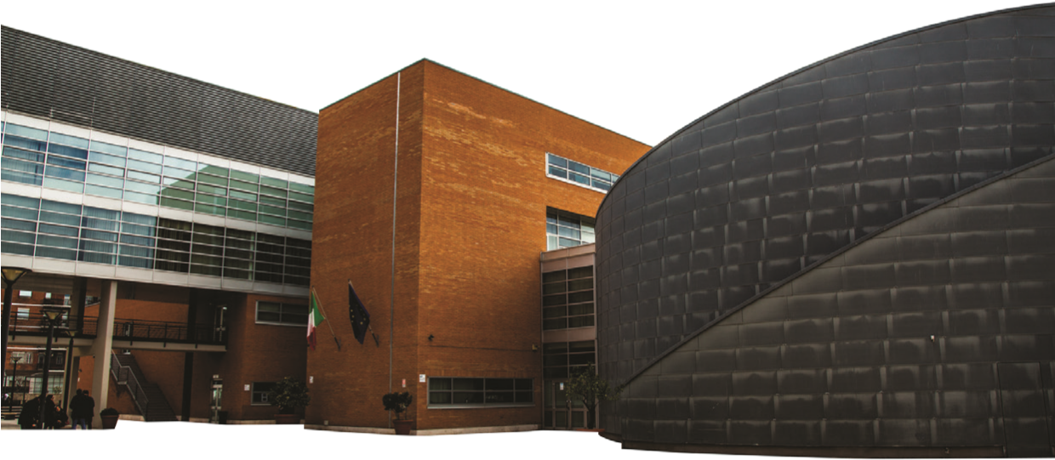
Manlio Rossi-Doria Centre
for Economic and Social Research
Roma Tre University
CRES
Monday 1 March 2021
18th GDS17 Meeting

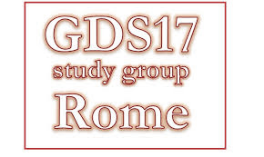

14:30-14:45 Welcome (Davide Vurchio, Università degli Studi di Bari “Aldo Moro”)

14:45-15:30 International competitiveness and Innovation System (IS): an analysis for the aerospace industry (Thiago Caliari, Instituto Tecnológico de Aeronáutica, Sao Paulo, Brazil)

15:30-15:45 Break and discussion

15:45-16:15 PhD presentation: An analysis of retailers-driven value chains and global value chains in the French agri-food industry (Kossi Messanh Agbekponou, INRAE, UMR SMART-LERECO)

16:15-16:30 Discussion and Concluding remarks

Link to the webinar: Riunione | Microsoft Teams

